“NEWS AGGREGATOR SYSTEM”
MINI PROJECT 1B
BACHELOR OF COMPUTER SCIENCE AND DESIGN

By
Disha Birari 12327014
Bhakti Patil 12217011
Soham S Bhere 12217012
Shafe Ahemad 12347003

Guide:
Mrs. Swati Patil



Department of Computer Science & Design
New Horizon Institute of Technology and Management,
University of Mumbai

Department of Computer Science & Design
New Horizon Institute of Technology and Management,
University of Mumbai

CERTIFICATE

This is to certify that the mini-project entitled “NEWS AGGREGATOR SYSTEM” , SECSD13 of

Sr.No. Name of the Student IEN No.
1 Disha S. Birari 12327014
2 Bhakti A. Patil 12217011
3 Soham S. Bhere 12217012
4 Shafe Ahemad 12347003

Has satisfactorily completed the mini project -1B in partial fulfillment of the requirement for the award of the Degree of Bachelor of Engineering in “Computer Science & Design”.

(Mrs. Swati Patil)

Mini-Project Guide

Dr. Niranjan Kulkarni Dr. P. D. Deshmukh Head of Department
Principal

Department of Computer Science & Design
New Horizon Institute of Technology and Management,
University of Mumbai

Mini-Project -1B Report Approval for S.E.

This project report entitled “NEWS AGGREGATOR SYSTEM” by Disha Birari , Bhakti Patil , Soham Bhere and Shafe Ahemad is approved for the degree of Bachelors in Computer Science And Design,
2024-25.

Examiner Name Signature
1. Name

2. Name

Date:

Place:

Department of Computer Science & Design
New Horizon Institute of Technology and Management,
University of Mumbai

Declaration

We declare that this written submission represents my ideas in my own words and where others' ideas or words have been included, I have adequately cited and referenced the original sources. I also declare that I have adhered to all principles of academic honesty and integrity and have not misrepresented or fabricated or falsified any idea/data/fact/source in my submission. I understand that any violation of the above will be cause for disciplinary action by the Institute and can also evoke penal action from the sources which have thus not been properly cited or from whom proper permission has not been taken when needed.

Disha Birari 12327014

Bhakti Patil 12217011

Soham Bhere 12217012

Shafe Ahemad 12347003

Date:

Department of Computer Science & Design
New Horizon Institute of Technology and Management,
University of Mumbai
Acknowledgement
We extend our sincere and heartfelt thanks to our esteemed guide Prof. Priyadarshini B., for providing us with the right guidance and advice at the crucial junctures and for showing me the right way. We also take this opportunity to express a deep sense of gratitude to our coordinator Ms. Priyadarshini B. for their cordial support, valuable suggestions and guidance. We extend our sincere thanks to our respected Head of department Dr. Niranjan Kulkarni, for allowing us to use the facilities available. We would like to thank the other faculty members also, at this occasion. Last but not the least, we would like to thank our friends and family for the support and encouragement they have given us during our work.

1.Disha Birari

2.Bhakti Patil

3.Soham Bhere

4.Shafe Ahemad

Abstract

In the digital age, the rapid growth of online news creates an overwhelming amount of information, making it difficult for users to stay informed. This project focuses on automatic news summarization using Natural Language Processing (NLP) with an abstractive approach to address this challenge. Unlike extractive methods that pull key sentences directly from the text, abstractive summarization generates new sentences by understanding and rephrasing the content.

The system uses advanced transformer-based models like BART and T5 to process news articles, extract the core message, and produce concise, human-like summaries. The workflow involves data collection from news sources, text preprocessing, model-based summarization, and post-processing for coherence and fluency. The model's performance is evaluated using metrics like ROUGE and BLEU to ensure accuracy and relevance.

This project has practical applications in news aggregation platforms, media monitoring, and content curation, enabling users to access essential information quickly. Future enhancements include multi-document summarization, improved coherence, and personalized summary generation for better user experience.

Table of Content

0.1 ……….………………………………………………….………………………………….. ..I
0.2 Certificate……….………………………………………………….……………………. .. .II
0.3 Certificate……….………………………………………………….……………… III (I,II)
0.4 Declaration……….………………………………………………….………………….…. IV
0.5 Abstract……….………………………………………………….…………… ……...… . .V
1.0 Introduction……….………………………………………………….………… ..………..1
2.0 Literature Survey……………………………………..……………………… ..………….2
2.1 NEWS AGGREGATOR SYSTEM ……………………………………………………2

3.0 Problem Statement, Objectives and Scope …..……………….………...………………..5
3.1 Problem Statement …………………………………………..… .… ……...…...…..5
3.2 Objectives………………………………………………….… .....………............…6
3.3 Scope……………………………………………………….…...…………….....…..6
4.0 Proposed System…………………………………………………….……………...……...7
5.0 Implementation………………………………………………….………………..……….11
5.1 Harware and software Requirment…………………………………………………11
5.2 Schedule Table……………………………………………………..……...........…..12
6.0 Expected Outcome………………………………………………………………...….…...13
7.0 Conclusion…………………………………………………………………………………15
7.1 Conclusion…..……………………………………………………………..........….15
7.2 Future Scope…..……………………………………………………………...…….15
8.0 References …………………………………………………………………..….…….16

List of Figures

Fig.No. Content Page No.
1. Fig 1-Workflow 9
2. Fig 2- Expected Outcome 10

CHAPTER 1

INTRODUCTION

Introduction
In today’s fast-paced world, staying informed about the latest news and events is more important than ever. However, with the overwhelming amount of information available, it can be challenging to keep up with everything. This is where news aggregation comes in – the process of creating a condensed version of a news article or document that captures the essential information and key points.

With the rise of natural language processing (NLP) techniques and tools, automatic news summarization has become a popular area of research. The ability to extract the most important information from a large News corpus and present it in a concise format has many potential applications, from news aggregation and personalized content recommendation to legal document analysis and financial news monitoring.

News Aggregator system is the process of condensing a large news article or document into a shorter version, while retaining the important information and conveying the main idea. With the advent of NLP techniques, automatic news summarization has become a popular area of research. In this min project, the various NLP techniques and tools for news summarization are used. We will start by collecting a corpus of news articles, and pre-process the data to clean and to kenize the News. The challenges and limitations of news summarization, such as dealing with ambiguity, maintaining coherence, and preserving the author’s intent can be identified and managed.

CHAPTER 02

LITERATURE SURVEY

2.1 News Aggregator System
A News Aggregator System collects and summarizes news articles from multiple sources, providing users with a consolidated and organized view of current events. This system uses Natural Language Processing (NLP) and Machine Learning (ML) techniques to extract, summarize, and present key information efficiently. The following literature survey reviews significant research and technological advancements in the development of automated news aggregation and summarization systems:

- Traditional News Aggregation Approaches
- Modern NLP Techniques for News Summarization
- News Aggregation Using APIs
- Evaluation Metrics for News Summarization
- Future Directions in News Aggregation Systems

The evolution of news aggregator systems has advanced from rule-based techniques to deep learning models capable of generating abstractive summaries. While modern methods like BART and T5 offer high-quality outputs, challenges remain in ensuring factual accuracy, reducing computational costs, and delivering personalized content. Future improvements will focus on multi-source integration, better evaluation methods, and user-centric delivery.

Limitations
- Data Quality – Risk of misinformation and inconsistency across sources.
- Summarization – Loss of context, accuracy issues, and information overlap.
- Technical – High computational demands, scalability issues, and latency.
- Personalization – Bias reinforcement and limited content diversity.
- Evaluation – Challenges in accurately assessing and monitoring content.

While news aggregator systems offer efficient and automated ways to consolidate news from multiple sources, they still face several challenges and limitations.

  - Objectives

The primary goal of a News Aggregator System is to collect, process, and present concise and accurate summaries of news articles from multiple sources. This system enhances information accessibility, saves user time, and ensures diverse perspectives. The following are the key objectives:

  - Automate the collection of news articles from diverse sources.
  - Summarize news accurately using advanced NLP techniques.
  - Enhance user experience with organized and personalized content.
  - Ensure diversity and accuracy in the summarized output.
  - Evaluate and optimize system performance with robust metrics.
  - Deliver flexible summaries to cater to various user needs

Future Scope of the News Aggregator System

As technology advances and user demands evolve, there are numerous opportunities to enhance the News Aggregator System. Future improvements can focus on increasing accuracy, enhancing user experience, and integrating advanced AI capabilities. Below are key areas for future development:

- User Authentication & Personalization:
- News Recommendations:
- Multi-Language Support:
- Voice Search and Text-to-Speech:
- Live News Updates & Streaming:
- Offline Access:
- Collaborations with Journalists & Publications:
- Advanced Search & Filters:
- Mobile App Integration:
- Monetization Opportunities:.

CHAPTER 3

PROPOSED SYSTEM

3.1 Proposed System

The proposed system consists of several key components to ensure efficiency, scalability, and user engagement.
4.1 Environment: The system is deployed on a web server, allowing users to access the platform via a browser on desktop and mobile devices. The backend is built with Django, ensuring smooth communication with the GNews API, while the front end is designed to be lightweight and responsive.
4.2 User Interface: A well-structured and intuitive interface allows users to browse, search, and filter news articles effortlessly. The UI is designed using HTML, CSS, and JavaScript, ensuring an optimal user experience.
4.3 Real-time News Updates: The system fetches news from the GNews API at regular intervals to ensure users have access to the latest articles from various sources.
3.4 News Categorization: Articles are categorized by topics such as politics, technology, business, sports, and entertainment. This allows users to quickly find content relevant to their interests.
3.5 Search and Filtering Features: Users can search for specific news articles using keywords or filter articles by date, source, or category, improving accessibility and user experience.
3.6 Responsive Design: The system is fully responsive, allowing users to access the platform on desktops, tablets, and smartphones without any performance issues.
3.7 Security Measures: Basic security measures, such as API request validation, error handling, and secure content rendering, are implemented to ensure data integrity and protection against unauthorized access.
3.8 Future Enhancements: The system is designed to be scalable, with potential future enhancements such as AI-driven content recommendations, user authentication for personalized feeds, and multilingual support.

WORKFLOW

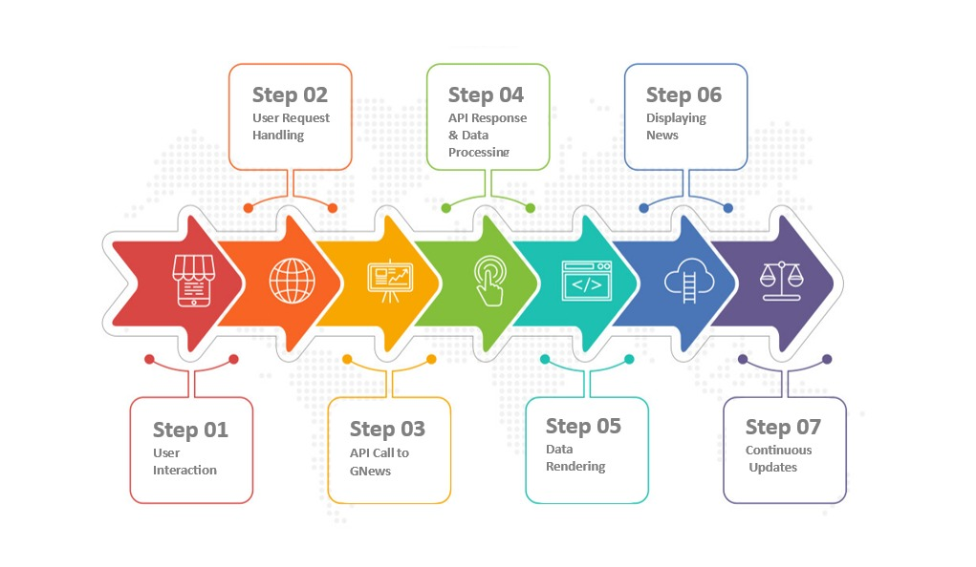

Fig 1: Flowchart

CHAPTER 4
IMPLEMENTATION

4.1 Hardware Software Requirment
1. Hardware
Windows Requirements
RAM: 4 GB
CPU: Intel Pentium
Web Browser: chrome, firefox, etc.
OS: Windows 8
Android Requirements
RAM: 4 GB
processor: Snapdragon 425
Network: Internet Connection 4g/5g.
OS: Android 10

2.Software
1.Integrated Development Environment (IDE): Visual Studio Code (VS Code) Version: 1.83.1.
2.Backend: i) Python 3.13.2 ii) Django framework 5.1.7
3.API Integration: GNews API (for fetching real-time news data)
4.Markup Language: Hypertext Markup Language (HTML5) Version: 4.01.
5.Styling: Cascading Style Sheets (CSS) Version W3.CSS.
6.Scripting language: JavaScript (JS) Version: ES2024.

4.2 Implementation Plan

Week 1 | Discussion of topic
Week 2 | Gathering information & learning language
Week 3 | Confirmation of topic
Week 4 | Project Setup
Week 5 | API Integration
Week 6 | Core Features Development
Week 7 | User Interface
Week 8 | System Optimization

CHAPTER 6
Expected Outcome
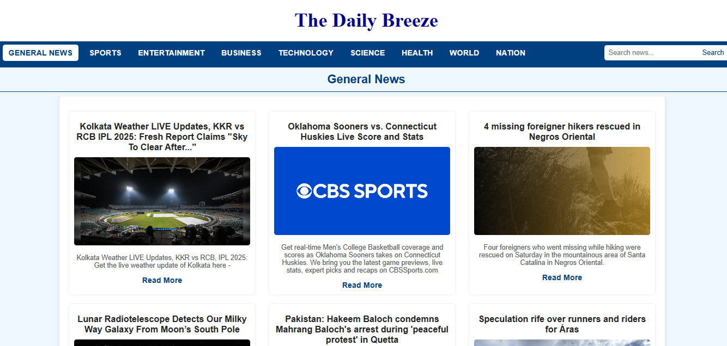

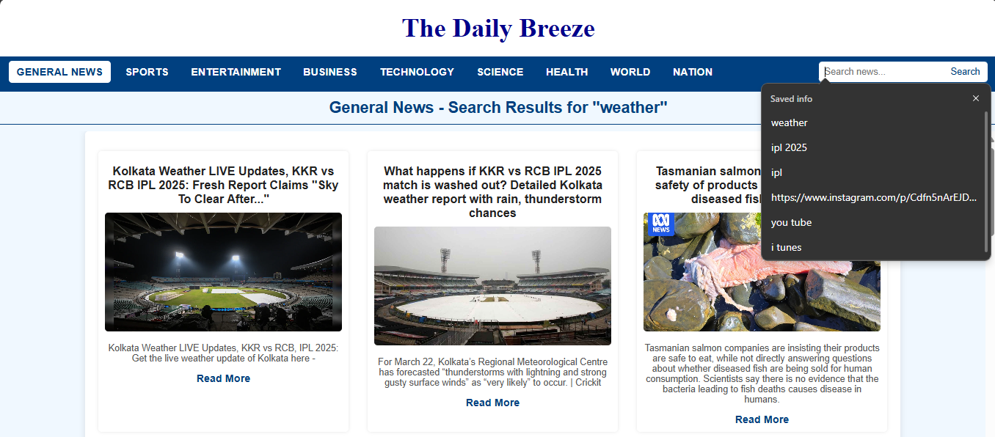

CONCLUSION

The News Aggregator System provides an efficient and automated platform to collect, summarize, and present news from multiple sources. By leveraging Natural Language Processing (NLP) and machine learning techniques, the system delivers concise and accurate summaries, enhancing user accessibility and saving time.
The system ensures real-time updates, organizes news by categories, and offers a user-friendly interface for seamless navigation. With features like personalized recommendations and multi-source aggregation, it provides a comprehensive view of current events while minimizing information overload.
Although the system successfully addresses many challenges in news collection and summarization, future enhancements can focus on improving factual accuracy, bias detection, and scalability. Integrating advanced AI models, real-time verification, and cross-platform support will further elevate the system’s capabilities.
In conclusion, the News Aggregator System is a robust and scalable solution that simplifies access to diverse news sources while offering accurate and timely summaries. It holds significant potential for continuous improvement and future innovation in delivering high-quality, personalized news experiences.

REFERENCE

[1] "News Aggregator Web Application Using Django -July 2025. chrome-extension://kdpelmjpfafjppnhbloffcjpeomlnpah/https://ijcrt.org/papers/IJCRT2107231.pdf
[2] "Build a News Aggregator Like Google News" by Pratik Dhakal. Inspiring Lab, December 2, 2024. https://inspiringlab.com.np/build-a-news-aggregator-like-google-news/?
[3] "How I Designed a News Aggregator Web Application Using Django" by Jonathan Okah. Finxter, May 15, 2023 https://blog.finxter.com/how-i-designed-a-news-aggregator-web-application-using-django/
[4] "Building News Aggregator Web App with Django Using Python Web Scraping" by Rajan Kumar. HackersFriend, January 12, 2020 https://inspiringlab.com.np/build-a-news-aggregator-like-google-news/?utm_source=chatgpt.com
[5] "Build a News App Using Django" by Max. DEV Community, August 15, 2020. https://dev.to/max236/news-app-in-django-2dcd

